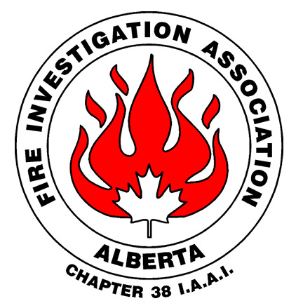

Notice of Annual General Meeting

of the

Fire Investigation Association of Alberta
Chapter 38, International Association of Arson Investigators

TAKE NOTICE THAT an Annual General Meeting of the members of the Fire Investigation Association of Alberta will be held at the Calgary Fire Department Fire Training Academy located at 5727 – 23 Avenue SE, Calgary, Alberta, on the 6th day of September, 2023, at about the hour of 17:15 in the afternoon for the following purposes:

1. To consider the financial statements for the year ending September 30, 2022
2. To appoint an auditor for the financial year October 1, 2022, to September 30, 2023;
3. To approve any amendments to the Bylaws;
4. To ratify the appointment of directors and officers for 2023 – 2024 ;
5. To transact any other business as may properly come before the Members of the Fire Investigation Association of Alberta prior to any adjournment thereof.

DATED this fourth day of July 24, 2023

